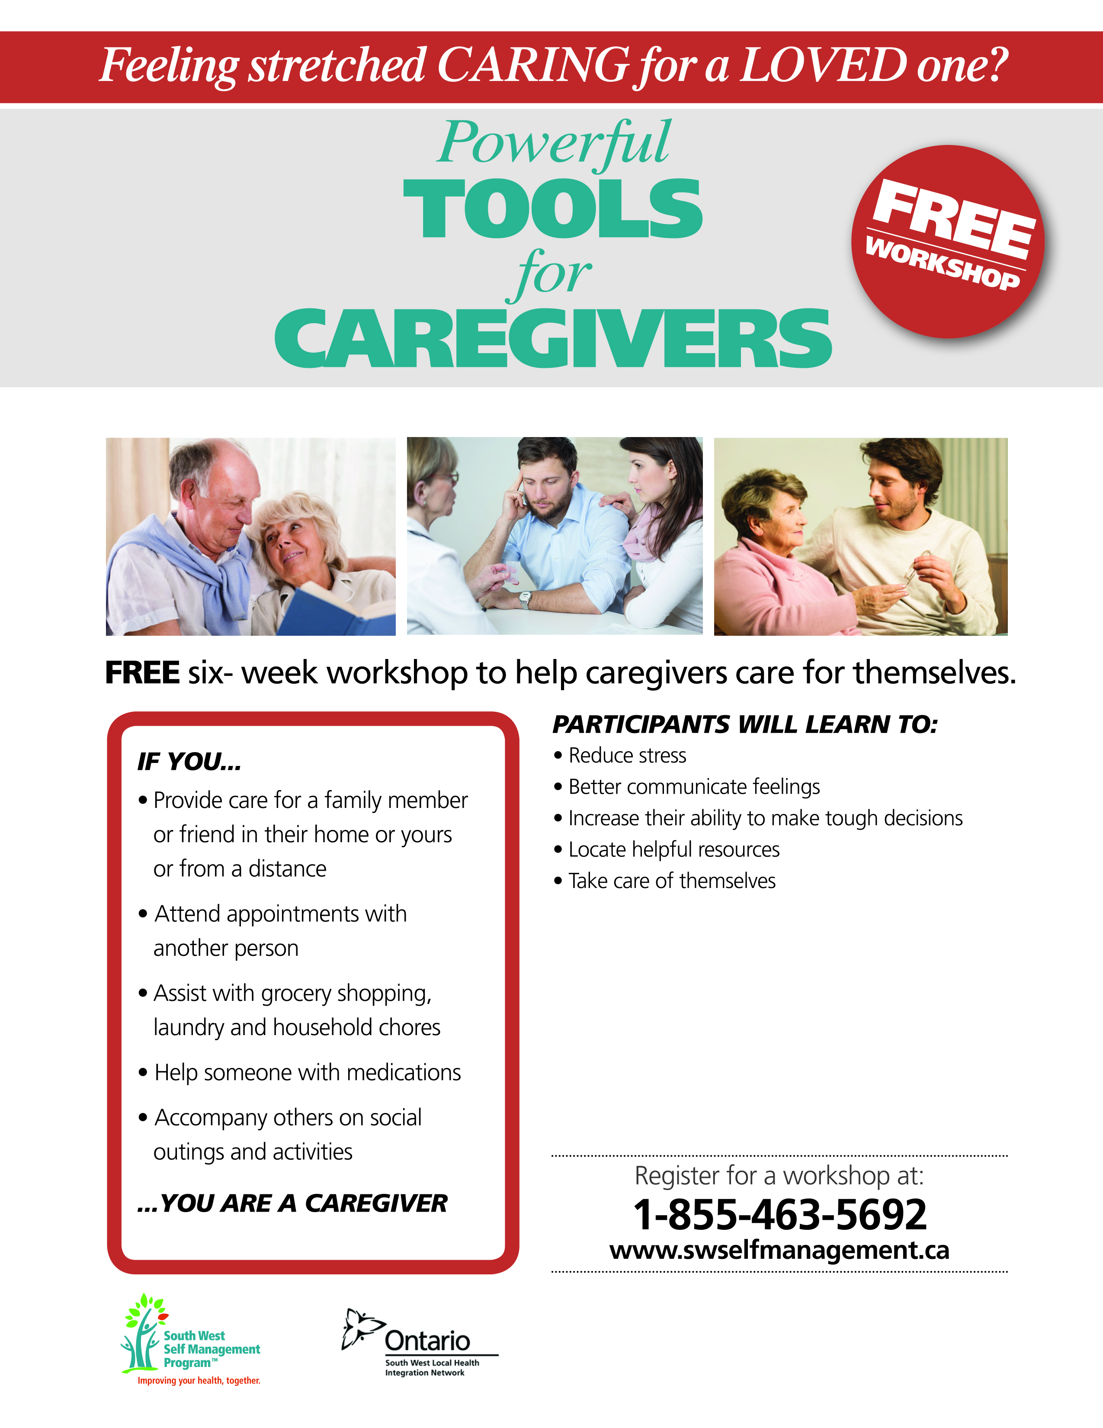

**Monday 9:30 to 11:30**

**March 4 to April 8, 2019**

**Family Services Perth-Huron**

**142 Waterloo St. S., Stratford**

Register at 519 273 1020 or